**Required Drills:**

* Fire Drills – Monthly
* Lock Down Drills – Once a Semester
* Tornado Watch Drill – Once a Year
* Tornado Warning Drill – Once a Year

**Fire Drills:**

* View primary and secondary exit routes posted in your classrooms
* Take your roster and report to your designated evacuation area (see map)
* Take attendance
  + Do Not Congregate in Hub Areas if the gate is closed. Find alternative route
  + Re-enter any building after exiting

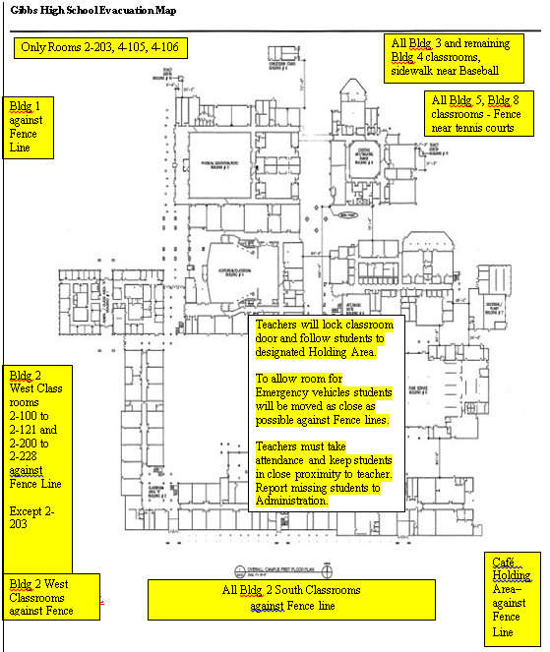

**Lock Down Drills:**

* Teachers turn off lights, care should be used to insure that students/staff near their classroom are not trapped in the hallway, lock their classroom doors, and recheck attendance, direct students to remain quiet and move towards the interior walls away from windows and doors and to get low to the ground. Teachers lock all windows, close blinds
* Teachers immediately make a list of missing students on their class roster and their last known location. Then make a list of (Guest students/staff) not on their class roster now under their control. Teachers make sure students remain in their classroom as long as the crisis exists
* **Only the principal can give the “all clear”**
* When the campus is secured, Gibbs administrators will walk the campus, unlock classroom doors, and call ‘All-Clear”. An announcement will be made to apprise staff and students of the nature of the emergency, quell rumors, and provide any release instructions. **Do not unlock doors, Gibbs Administration will unlock the door**
* When the crisis is over, the Bell Schedule will resume or be revised. Teachers email their Cohort Administrator of any missing students or Guest students/staff in their room during lockdown.

**Tornado Watch:**

* + ***Administrators*** will round up students in outside areas and direct them indoors.
  + ***Teachers***will keep students in their classrooms, take roll and account for all students. Classes may continue
  + No hall passes until all clear is sounded.

**Tornado Warning:**

* ***Staff members*** move to an interior sturdy wall or hallway and assume the **duck and cover position**. Do not go outdoors
* ***Teachers***move all students to an interior sturdy hallway wall away from window areas, account for all students and assume the **duck and cover position**. Do not go outdoors
* ***Teachers in HUB Areas classrooms*** move their students into the hallways on the 2nd floor, away from window areas, account for all students and assume **the duck and cover position**
* Electric power will be cut off
* Principal will give the all clear.